**Data Perspective: Evolution of Education for 4- to 5-Year-Old Children in Zimbabwe**

**Introduction**

This Data Perspective examines the evolution of educational performance among 4- to 5-year-old children in Zimbabwe, using data from the 2019 Zimbabwe Multiple Indicator Cluster Survey (MICS6). The analysis focuses on literacy-numeracy, physical, socio-emotional, learning and early child development index score.

**Methodology**

The data for this analysis come from 2019 Zimbabwe MICS6 survey, especially the section about Mother/Caregiver interview for children under 5. Children aged 3 or 4 were considered. The analysis was conducted using Stata 17. The indicators include:

* **Literacy and numeracy skills**: The ability of children to recognize letters, numbers or read simple words.
* **Physical growth**: The ability of children to pick up small objects or the fact that children are not sometimes too sick to play.
* **Readiness to learn**: The ability of children to follow simple directions on how to do something correctly or to do something independently.
* **Socio-emotional development**: The ability of children to get along well with other children, not getting distracted easily or not kick, bite or hit other children.
* **Early child development index**: Involves an ordered progression of motor, cognitive, language, socio-emotional and regulatory skills and capacities across the first few years of life.

**Key Findings**

**Literacy and Numeracy**

The analysis reveals that 90% of children aged 3 or 4 in Zimbabwe, lack literacy and numeracy skills.

*Figure 1: Literacy and numeracy rates for children aged 3 or 4*

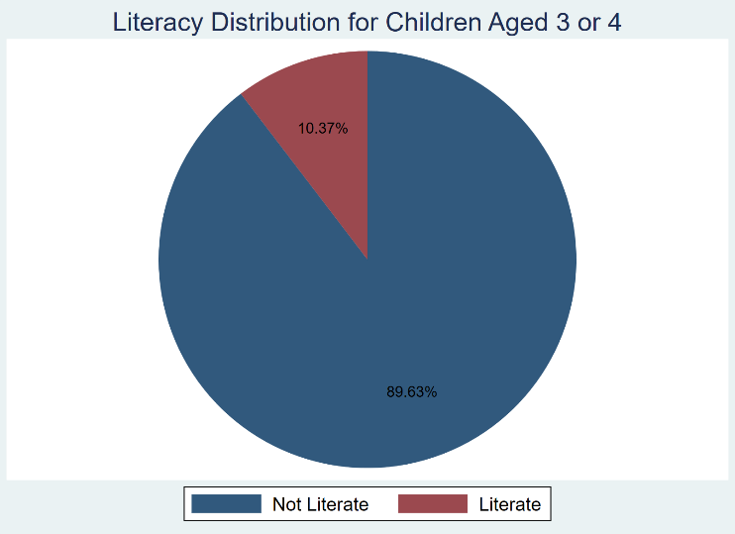

**Early child development index (ECDI)**

The analysis reveals that 60% of children aged 3 or 4 in Zimbabwe has a good ECDI. This shows an overall adequate development.

*Figure 2: Early child development index status for children aged 3 or 4*

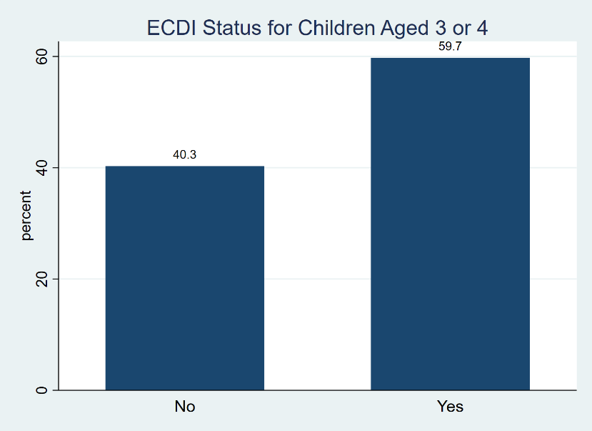

**Interpretation**

Despite the low level of literacy, the early child development index is quite good. There

The findings indicate an overall adequate development of children aged 3 or 4 in Zimbabwe. However, 40% of children are not reaching their full development potential. This is mainly due to the low level of literacy which could predict difficulties as these children progress into more formal schooling at age 5 and beyond.

**Conclusion**

The findings reveal a significant gap in early childhood education in Zimbabwe, with only 10% of 3- to 4-year-olds being literate, despite 60% showing good overall development according to the ECDI. This suggests that while many children are developing well in general, literacy skills are notably lagging. Targeted interventions are needed to improve early literacy rates to ensure holistic development and better future outcomes.

**References**

* Zimbabwe MICS6 Survey 2019 Data.